# Manual Testing of API Data

1. Forex Calculator
2. Weather Guide based on user input
3. Holiday list based on User entered country and year

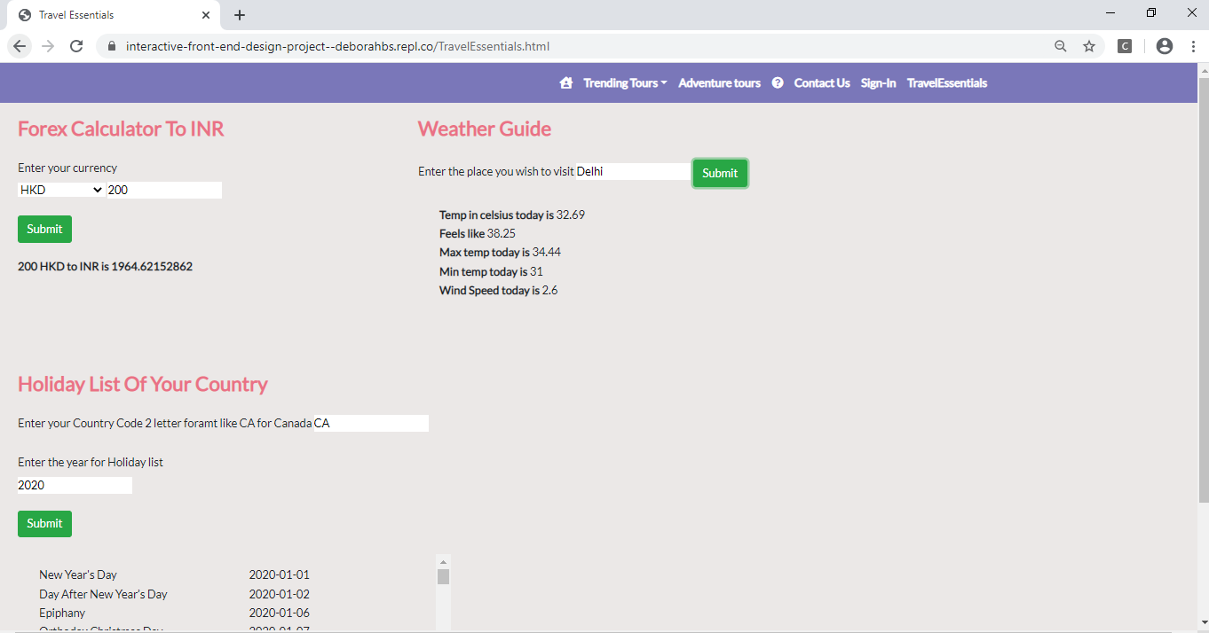

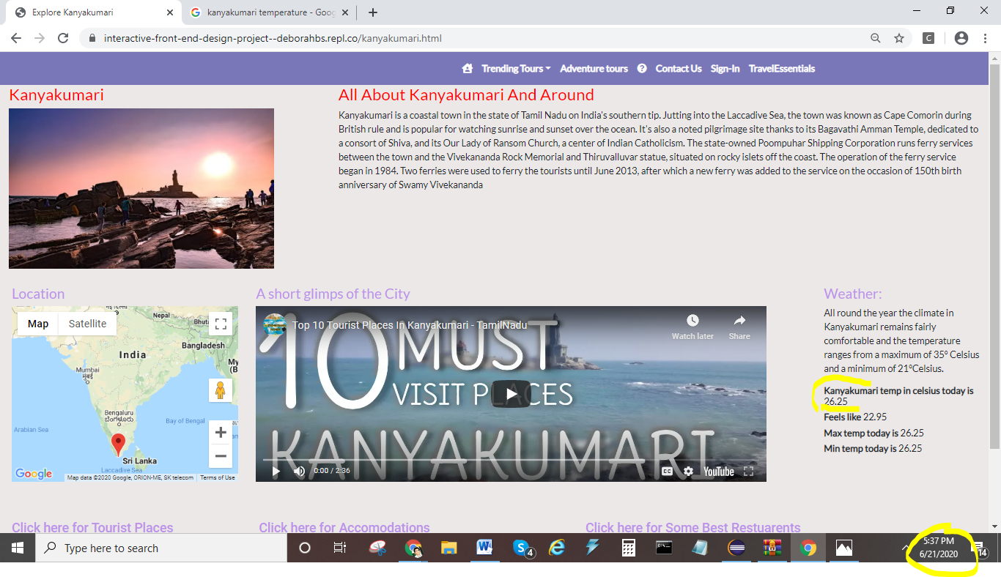

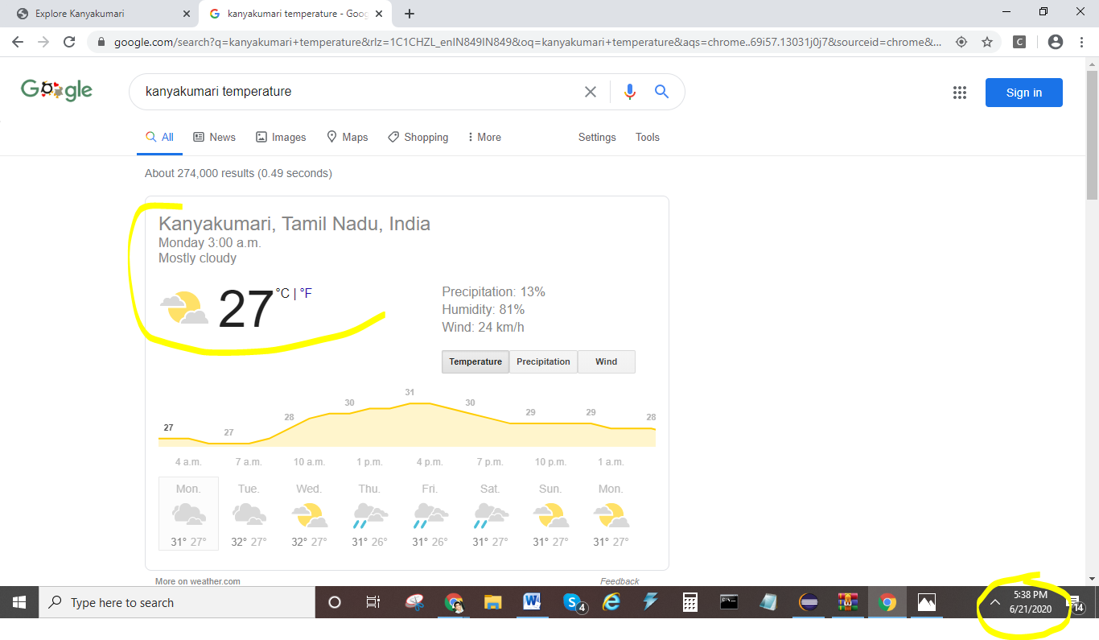

API for

1. Tourist attractions
2. Accommodations
3. Restaurants

When clicked for Tourist places, Accommodations or Restaurants, DOM is manipulated and displays the data by calling the API

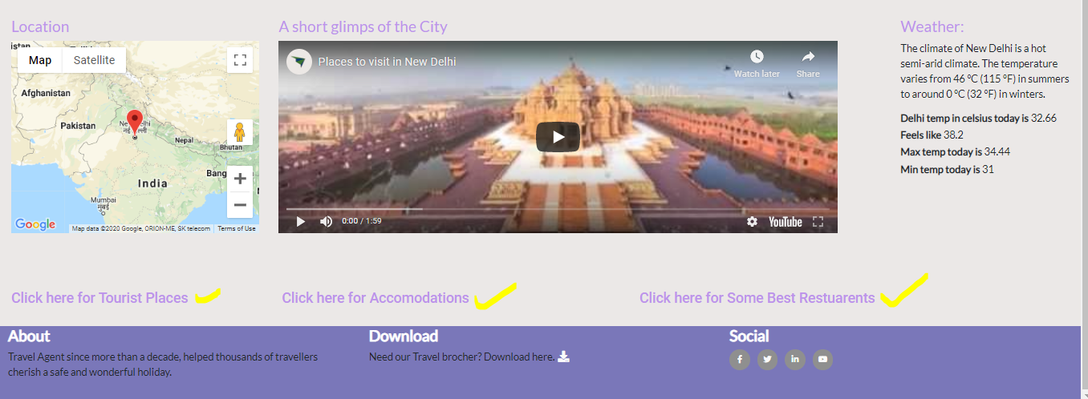

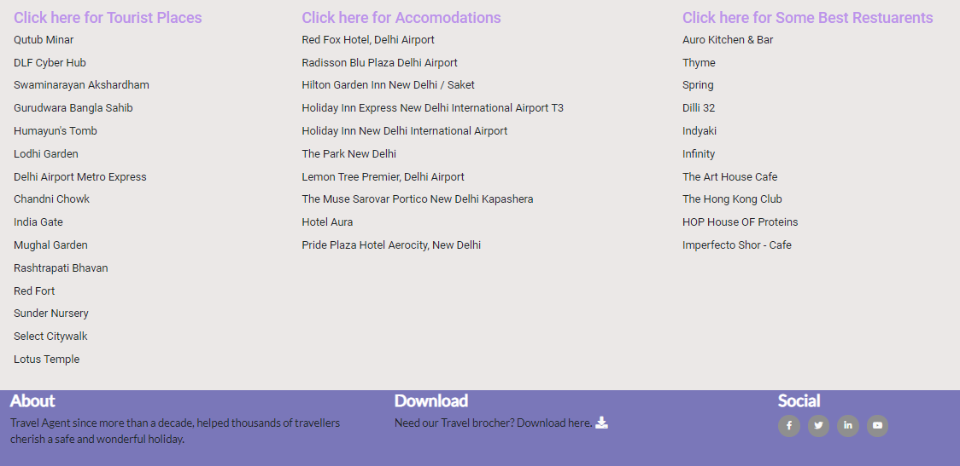

1. Email from ContactUs

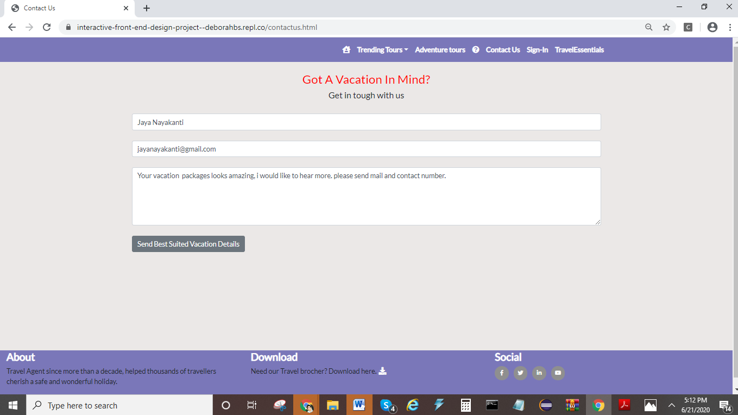

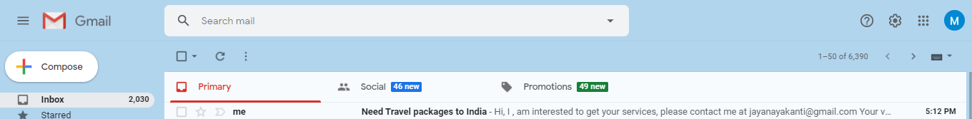

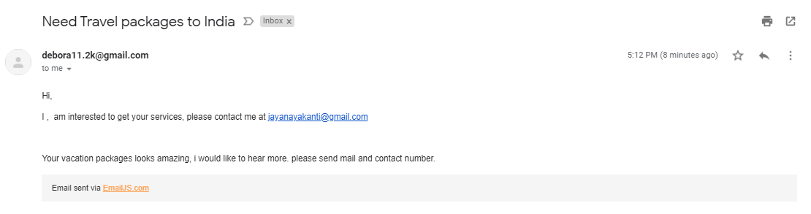

1. GoogleMaps API

